DATA PROTECTION: This form is used to collect information about your young person for the purpose of the activity named below, this is to be used by the activity instructors only. As part of this form we collect personal data about your young person, this detail is required so they can take part in the activity. This form also collects sensitive (special category) data about your young person, this detail is required so we can offer additional support if required and keep your young person safe whilst in our care. The form will be securely destroyed after the activity.

Witten parental permission is needed before a young person can take part in shooting activities.
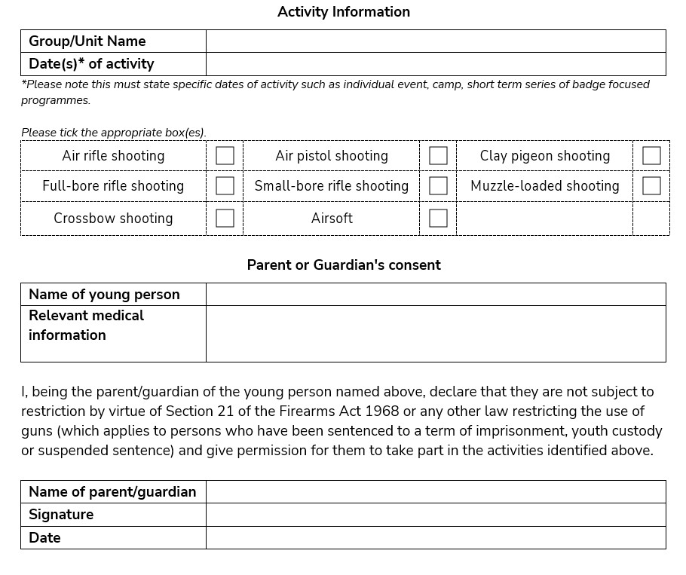
Lazer Tag
Version October 2021
Declaration for Shooting.
Extracts from the Firearms Act 1968
‘Section 21’
- A person who has been sentenced (to custody for life or) to preventive detention, or to imprisonment or to corrective training for a term of three years or more (or to youth custody (or detention in a young offender institution) for such a term), or who has been sentenced to be detained for such a term in a young offenders institution in Scotland, shall not at any time have a firearm or ammunition in his possession .
- A person who has been sentenced to imprisonment for a term of three months or more but less than three years ( or to youth custody ( or detention in a young offender institution) for such a term), or who has been sentenced to be detained for such a term in a detention centre or in a young offenders institution In Scotland, shall not at any time before the expiration of the period of five years from the date of his release have a firearm or ammunition in his possession.
- Where a person has been sentenced to imprisonment for a term of three months or more and the sentence is suspended under section 189 of the criminal Justice Act 2003 the person shall not have a firearm or ammunition in his possession during the period of five years beginning with the second day after the date that the sentence was passed.

This means: Section 21 prohibits the possession of a firearm and ammunition (under any circumstances), by any person who has been convicted of a crime and sentenced to a
term of imprisonment (or its equivalent for young persons) of 3 months or more, even if the sentence is suspended. The prohibition applies in all circumstances, including handling and firing at an approved shooting club or at a clay pigeon shoot where a certificate is not ordinarily required. It also applies to the possession or use of other categories of firearms and ammunition such as AIRGUNS or shot cartridges for which a certificate is not needed. A sentence of 3 months to 3 years attracts a 5-year prohibition, shorter ones no prohibition but a longer one means a life ban
Version October 2021

